# Task 1 (Understanding the System Workflow)

Source Code Description:

The OBOBO App is straightforward time management tool that encompasses three primary functionalities:

1. Stopwatch: The features enables users to initiate, halt, and reset a stopwatch to track the passage of time.
2. Lap timer: This function monitors laps while the stopwatch is active. Users can log individual lap times, and a list of these recorded laps is presented.
3. Alarm: This feature allows users to set an alarm that emits a sound and displays a notification when designated time is reached. Users have the option to set or cancel the alarm.

All functionalities are accessible via tabbed navigation, facilitating easy transitions between the stopwatch, Lap timer and Alarm features. Additionally, an instruction box is provided to offer a concise guide on utilizing the app, along with a footer for branding and copyright information.

Use Case Diagram:

The use case diagram for this application would incorporate following essential components:

Actors:

* Users

Use Cases:

* Start stopwatch
* Stop stopwatch
* Reset stopwatch
* Start Lap Timer
* Stop Lap Timer
* Record Lap
* Reset Lap Timer
* Set Alarm
* Cancel Alarm
* Alarm Rings

System: OBOBO App

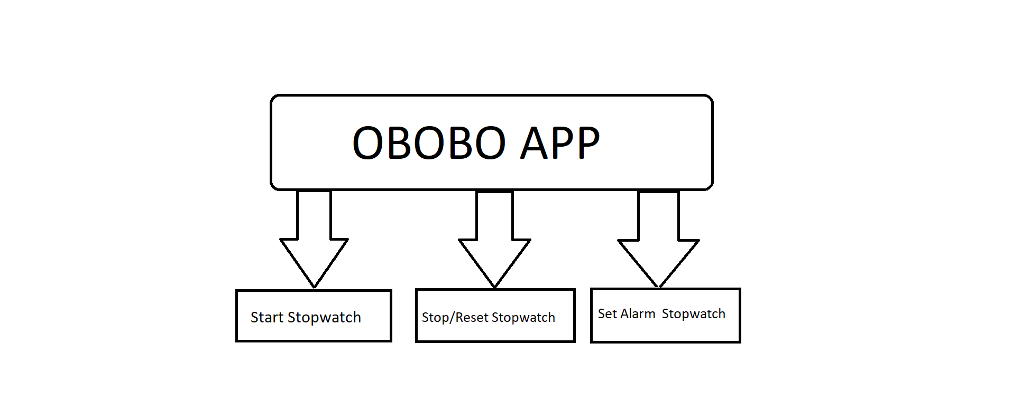

Test Environment:

To evaluate this application, the testing environment would consist of :

* Browsers: Conducting tests on major web browsers such as Chrome, Firefox, Safari, and Edge to ensure compatibility across platforms.
* Devices: Testing on both desktop and mobile browsers(responsive testing) to confirm the app’s functionality on various screen.
* Performance Testing: Assessing the accuracy of the timers(stopwatch, lap timer) across different browsers.
* Sound Testing: Verifying the alarm sound alarm feature to ensure the alarm activates correctly and can be canceled without complications.
* Functional Testing: Confirming that all buttons and interactions (start/stop/reset/record lap/set alarm) function as intended.

This summary encompasses all critical elements necessary for a comprehensive evaluation and testing of the OBOBO app.

# Task 2 (Create a Test Plan for the application)

|  |  |  |  |  |  |  |  |
| --- | --- | --- | --- | --- | --- | --- | --- |
| Test case ID | Test Case  Description | Preconditions | Test  Steps | Expected  Results | Actual  result | Pass/Fail | Comments |
| TC001 | Stopwatch Basic functionality | OBOBO App is loaded. | 1. Navigate to stopwatch tab. 2. Click Start. 3. Click Stop. 4. Click Reset. | Stopwatch starts, stops, and resets correctly. | Stopwatch started successfully, stopped as expected, and reset properly. | Pass | Functionality is working as intended. No issues. |
| TC002 | Lap Timer Basic Functionality | OBOBO app is loaded. | 1. Navigate to Lap Timer tab. 2. Click Start. 3. Click Lap multiple times. 4. Click Reset. | Laps are recorded accurately, and lap list resets when reset is clicked. | Laps were recorded correctly, and lap list | Pass | Functionality works as expected, no issues encountered. |
| TC003 | Alarm set Trigger | OBOBO app is loaded | 1. Navigate to Alarm tab. 2. Set alarm 1 minute ahead. 3. Verify alarm rings and displays notification. | Alarm rings at the correct time and displays notification, alarm sound plays. | Alarm triggered on time, displayed notification, and alarm sound played correctly. | Pass | Alarm worked as expected without any delay or issues. |
| TC004 | Tab Navigation | OBOBO app is loaded | 1. Click Stopwatch, Lap Timer, and Alarm tabs. 2. Verify correct content displays. 3. Switch between tabs. | Tabs switch correctly, displaying respective content; active tab is highlighted. | Tabs switched as expected, content displayed correctly, and active tab was highlighted. | Pass | Tab functionality worked seamlessly, no issues encountered. |
| TC005 | UI Responsiveness | OBOBO app is loaded. | 1. Resize window. 2. Test UI on mobile and tablet. 3. Check functionality of buttons on different devices. | UI adjusts to different screen sizes; buttons work correctly on all devices. | UI adjusted well to different screen sizes; buttons worked correctly on mobile and tablet | Pass | UI was responsive on all tested devices, and buttons functioned as expected. |
| TC006 | Cross- browser Testing | OBOBO app is loaded. | 1. Test Stopwatch, Lap Timer, and Alarm features on Chrome, Firefox, Safari, and Edge. | Application behaves consistently across all browsers. | Application behaved consistently across Chrome, Firefox, Safari, and Edge with no major issues observed. | Pass | No discrepancies in performance across browsers, all features worked as expected. |
| TC007 | Performance of Timers | OBOBOB app is loaded | 1. Start Stopwatch for 5 minutes. 2. Record lap times using Lap Timer. 3. Observe for any performance issues. | Timers run smoothly without delays or glitches. | Stopwatch and Lap Timer ran smoothly without delays or glitches. | Pass | Timers performed as expected with no lag or performance issues observed during the 5-minute test. |
| TC008 | Alarm Cancel functionality | OBOBO app is loaded. | 1. Set alarm. 2. Cancel alarm before it rings. 3. Verify alarm is canceled. | Alarm cancels and no alarm sound or notification occurs. | Alarm successfully canceled, no sound or notification occurred after canceling. | Pass | Alarm cancel functionality worked as expected, no sound or notifications were triggered. |

# Task 3 (Execute the Test Plan & Document the results)

|  |  |  |  |  |  |  |  |  |  |  |  |
| --- | --- | --- | --- | --- | --- | --- | --- | --- | --- | --- | --- |
| Test case ID | Test Case  Description | | Preconditions | Test  Steps | Expected  Results | | Actual  result | Pass/Fail | | | Comments |
| TC001 | Stopwatch starts counting time | OBOBO App is loaded, and Stopwatch tab is active | | 1. Click 'Start'.  2. Wait 5 seconds.  3. Click 'Stop'. | | Stopwatch starts counting from 00:00:00.00 and stops when 'Stop' is clicked. | Stopwatch starts and stops correctly | | Pass | 1.PNG | |
| TC002 | Test Stopwatch Reset | Stopwatch is stopped | | 1. Click 'Reset'. | | Stopwatch resets to 00:00:00.00. | Stopwatch resets to 00:00:00.00 as expected. | | Pass | 1.PNG | |
| TC003 | Test Lap Timer Start/Stop | OBOBO App is loaded, and Lap Timer tab is active | | 1. Click 'Start'.  2. Wait 5 seconds.  3. Click 'Stop'. | | Lap Timer starts counting from 00:00:00.00 and stops when 'Stop' is clicked. | Lap Timer starts and stops correctly. | | Pass | 2.PNG | |
| TC004 | Test Lap Timer Lap Recording | Lap Timer is running | | 1. Click 'Start'.  2. After 5 seconds, click 'Lap'.  3. After 10 seconds, click 'Lap' again. | | Each lap is recorded, showing elapsed time for each lap. | Laps recorded with proper timestamps. | | Pass | 2.PNG | |
| TC005 | Test Lap Timer Reset | Lap Timer is stopped | | 1. Click 'Reset'.  2. Verify that the lap list is cleared. | | Lap Timer resets to 00:00:00.00, and all lap records are cleared. | Timer reset, and lap list cleared correctly. | | Pass | 3.PNG | |
| TC006 | Test Alarm Set | OBOBO App is loaded, and Alarm tab is active | | 1. Enter a valid time (e.g., 14:30) in the time input.  2. Click 'Set Alarm'. | | Alarm is set for the specified time and displays confirmation message. | Alarm is set, and confirmation is displayed correctly. | | Pass | 4.PNG | |
| TC007 | Test Alarm Cancel | Alarm is set | | |  | | --- | |  |  |  | | --- | | 1. Click  'Cancel  Alarm'. | | | Alarm is canceled, display is cleared, and 'Set Alarm' button is restored. | Alarm canceled, display cleared as expected. | | Pass | 5.PNG | |
| TC008 | Test Alarm Sound | Alarm is set and time matches alarm time | | 1. Set the alarm for 1 minute ahead.  2. Wait until the alarm rings.  3. Confirm that the alarm sound plays. | | Alarm sound plays when the time matches the alarm set time. | Alarm sound plays correctly at the right time. | | Pass | Ensure sound file is loaded properly. | |
| TC009 | Test Tab Switching | OBOBO App is loaded | | 1. Click between the 'Stopwatch', 'Lap Timer', and 'Alarm' tabs. | | The correct tab content is displayed when each tab is clicked. | Tabs switch correctly, and content is displayed as expected. | | Pass |  | |
| TC010 | Test UI Elements Visibility | OBOBO App is loaded, various screen sizes | | 1. Resize the browser window to small, medium, and large sizes.  2. Verify that all elements are visible and accessible. | | UI elements should be fully visible and accessible on different screen sizes. | |  | | --- | | UI  elements  remain  visible  and  responsive  across all  screen size  s. |  |  | | --- | |  | | | Pass | Test on multiple browsers. | |

## Task 4 (Fix the errors in the code)

To debug the code and make sure that the code is functioning properly I have made some changes in the html, css, javascript.

|  |  |
| --- | --- |
| ERROR/ISSUES | CHANGES MADE |
| Time variable resetting on both stopwatch and lap timer. | Established distinct time variables for stopwatch Time and Lap Time to facilitate the management of independent timers. |
| Tab switching not resetting timers properly. | Implemented a reset feature during tab switching to guarantee that timers and halted and reset upon changing tabs. |
| Alarm not clearing when reset. | Refined the alarm logic to ensure that the timeout is effectively clearly, and the alarm display is reset upon cancellation. |
| Stopwatch and Lap Timer both running simultaneously. | Developed separate interval variables for the Stopwatch and Lap Timer to oversee distinct intervals. |
| Alarm sound playing multiple times | Introduced logic to avert the occurrence of multiple alarm sounds by pausing and resetting the sound when alarm is canceled. |
| Lack of user instructions. | Included user instructions in “How to Use” section to clarify the functionalities of a stopwatch, Lap Timer and Alarm. |

# Task 5 (Move the solution to a Live environment)